**Waleed Afzal – 23P-0566**

**Shawaiz Shahid – 23P-0599**

**SDA A#05**

**4CS**

1. **SD**

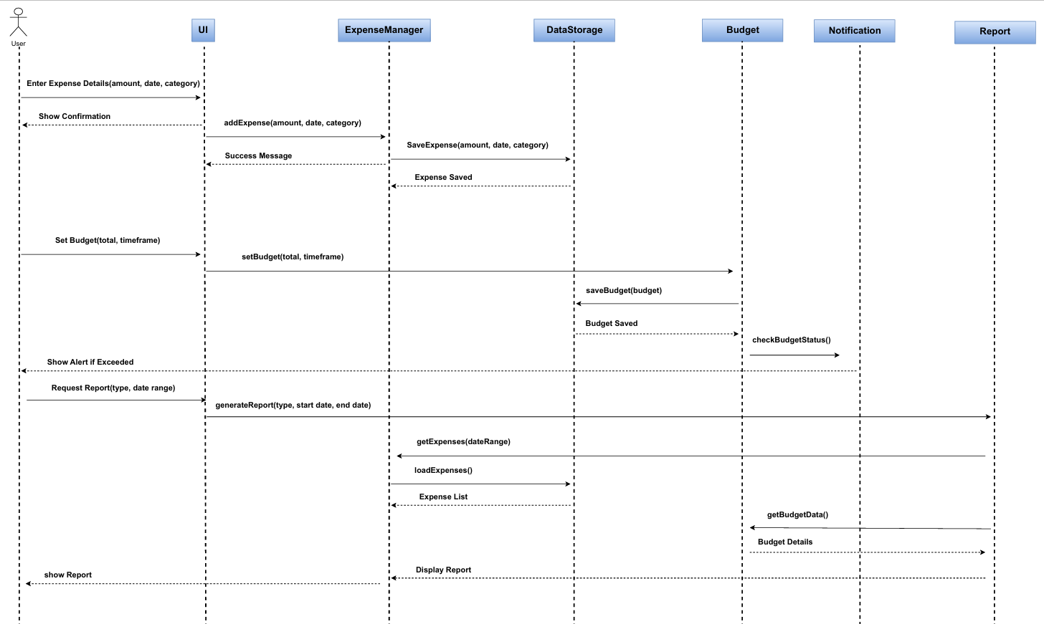

1. **SS**A diagram of a expense tracker system

   AI-generated content may be incorrect.**D**

**b.**

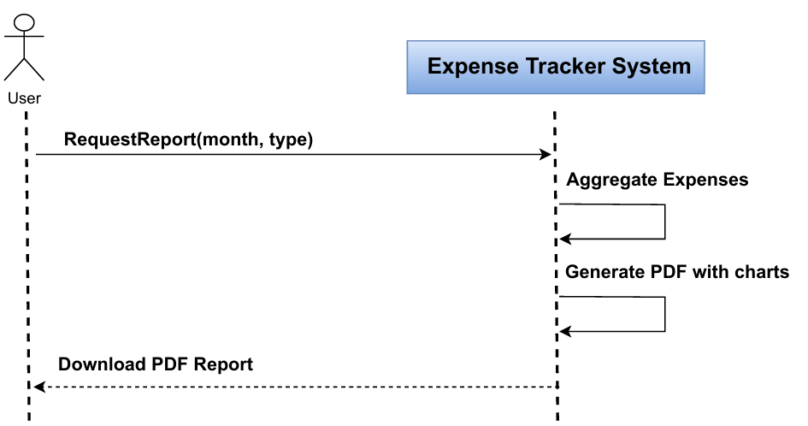

**c.**

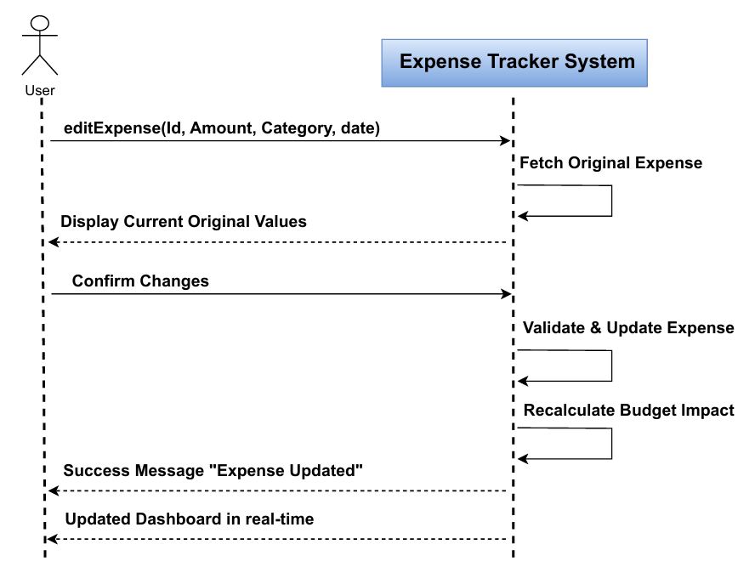

**d.**

1. **Collaboration Diagram**
   1. 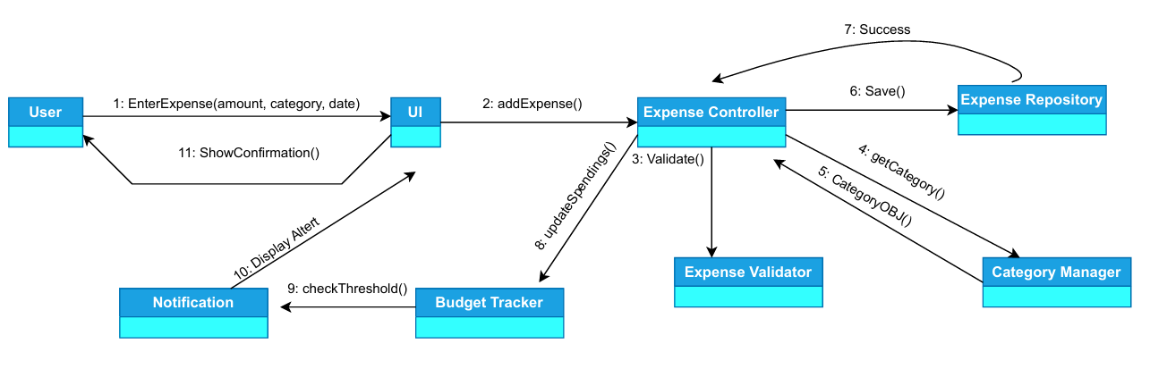
   2. **A diagram of a software process

      AI-generated content may be incorrect.**
2. **DFD (Level 0, Level 1 , Level 2):**
   1. **Level 0: A blue rectangle with black text

      AI-generated content may be incorrect.**
   2. **Level 1: A diagram of a budget

      AI-generated content may be incorrect.**
   3. **Level 2: A diagram of a company

      AI-generated content may be incorrect.**
3. **State Diagram**
   1. **A diagram of a process

      AI-generated content may be incorrect.**
   2. **A diagram of a software application

      AI-generated content may be incorrect.**
4. **Package Diagram**

1. **Component Diagram:**